**EXPERIMENT NO: 7**

**Aim: Develop a recommendation system by applying any machine learning technique and using available data set**

**Import Libraries:**

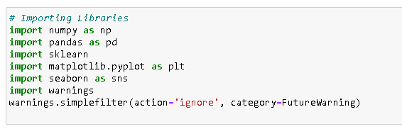

**loading rating dataset:**

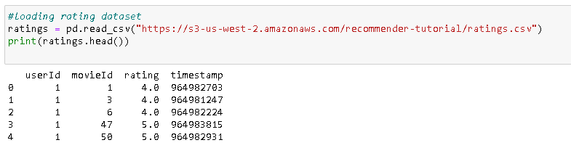

**loading movie dataset:**

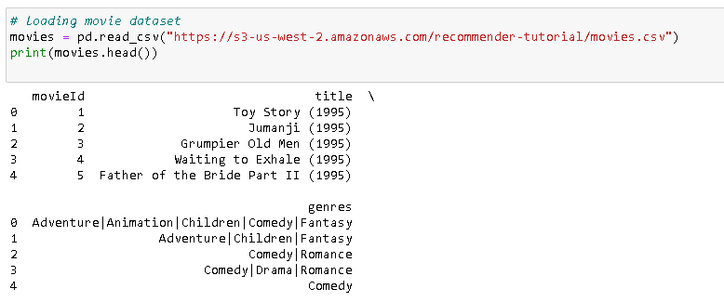

**Calculate number of ratings:**

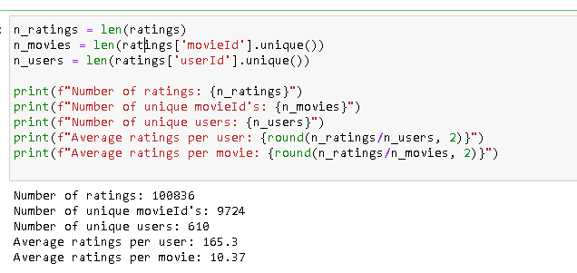

**Calculating mean ratings for each movie** 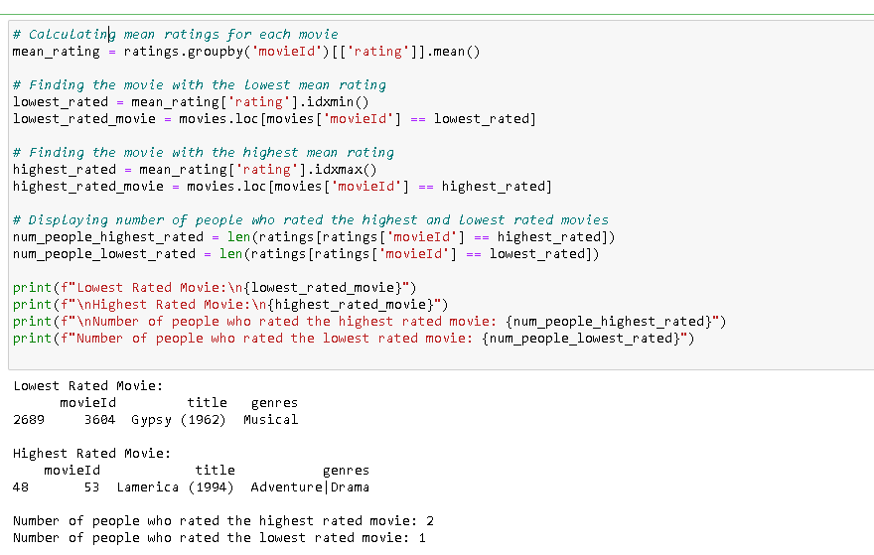

**Find similar movies using KNN:**

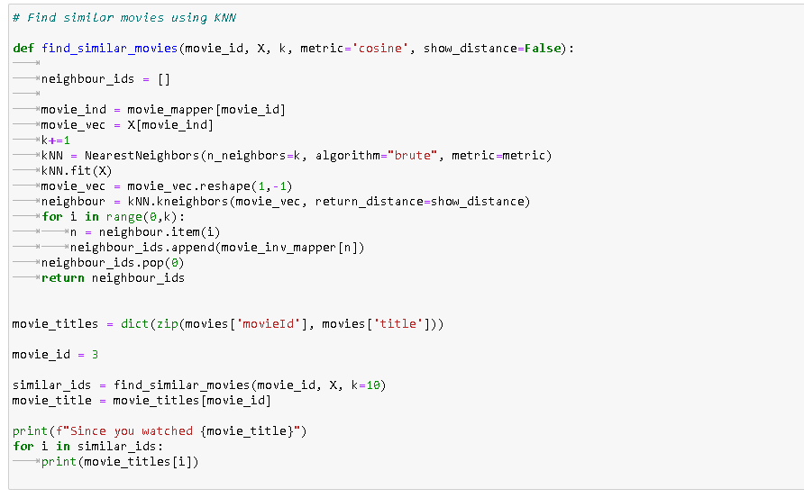

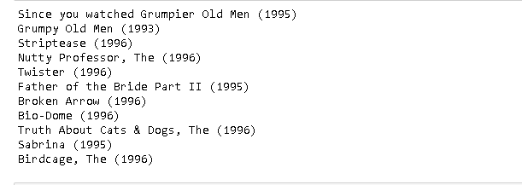

**Conclusion:**

Hence, we have successfully studied to implement **a similar movie recommendation system.**

.

**EXPERIMENT NO: 9**

**Aim: Develop a recommendation system by applying any machine learning technique and using available data set**

**Import Libraries:**

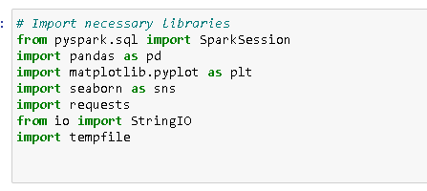

**Create a Spark session:**

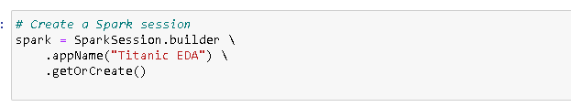

**loading the Titanic dataset :**

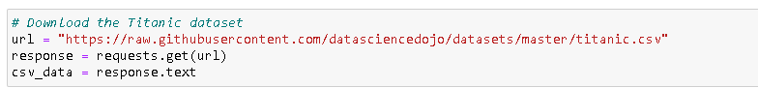

**Write CSV data to a temporary file:**

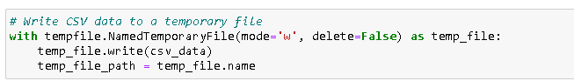

**Load the Titanic dataset using Apache Spark**



**Display Spark dataframe schema and first few rows:**

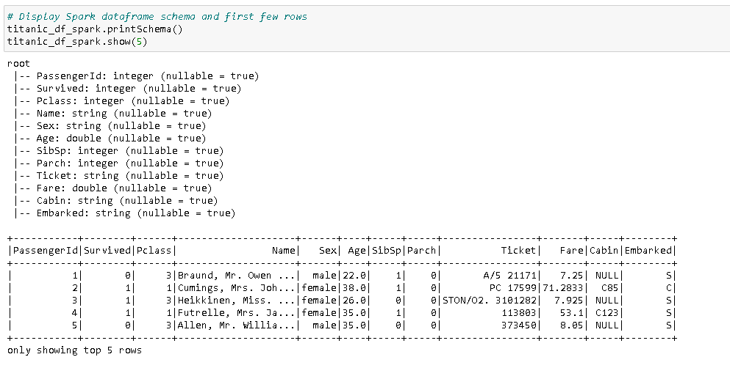

**Handling missing values in Spark:**

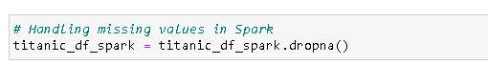

**Basic statistical analysis in Spark:**

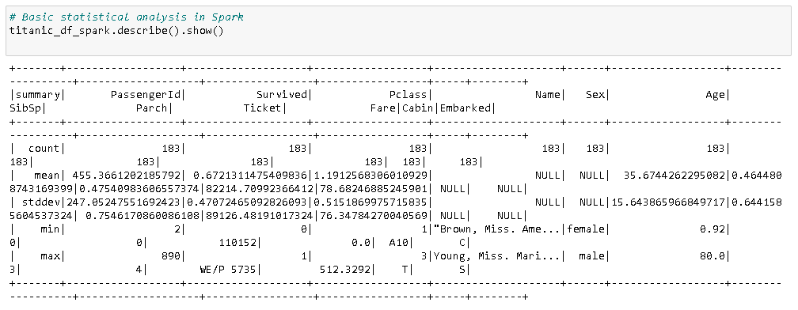

**Load the Titanic dataset using Pandas:**



**Display Pandas dataframe info and first few rows:**

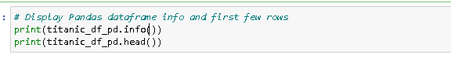

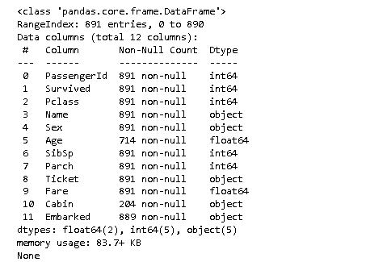

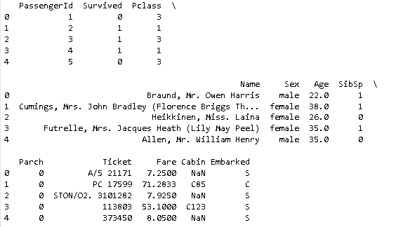

**Handling missing values in Pandas:**

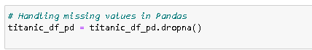

**Basic statistical analysis in Pandas:**

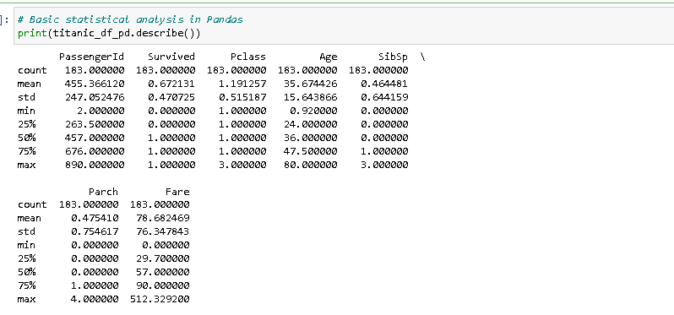

**Visualization with Pandas:**

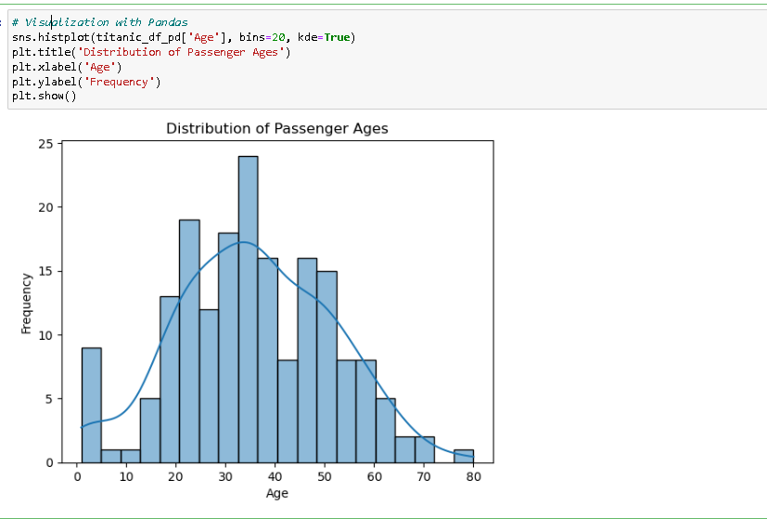

**Conclusion:**

Hence, we have successfully studied to implement **a similar movie recommendation system.**

.

**EXPERIMENT NO: 8**

**Aim: Develop a recommendation system by applying any machine learning technique and using available data set**

**Import Libraries:**



**loading rating dataset:**



**loading movie dataset:**



**Calculate number of ratings:**



**Calculating mean ratings for each movie **

**Find similar movies using KNN:**





**Conclusion:**

Hence, we have successfully studied to implement **a similar movie recommendation system.**

.

**EXPERIMENT NO: 10**

**Aim: Batch and Streamed Data Analysis using Spark**

**Import Libraries:**

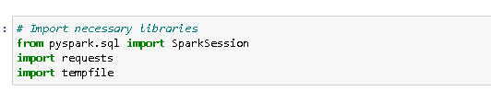

**Create a Spark session:**



**loading the Titanic dataset :**



**Write CSV data to a temporary file:**



**Load the Titanic dataset using Apache Spark**



**Display Batch Data Analysis:**

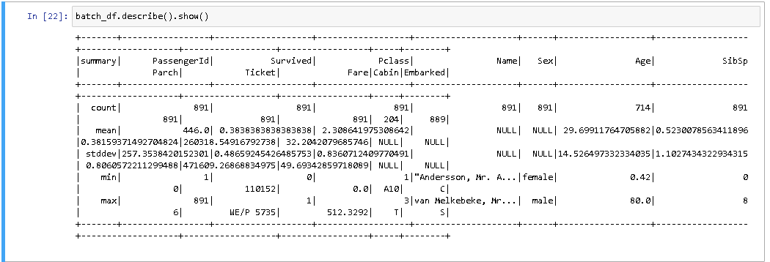

**Conclusion:**

Hence, we have successfully studied to implement **Batch and Streamed data analysis using Spark.**

.

**EXPERIMENT NO: 6**

**Aim: Classification modelling**

**a. Choose classifier for classification problem.**

**b. Evaluate the performance of classifier.**

**Import Libraries:**

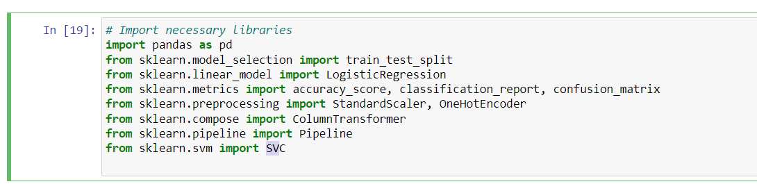

**Load the titanic dataset:**

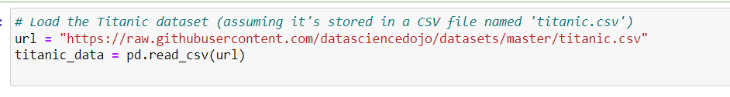

**Display the first few rows of the dataset:**

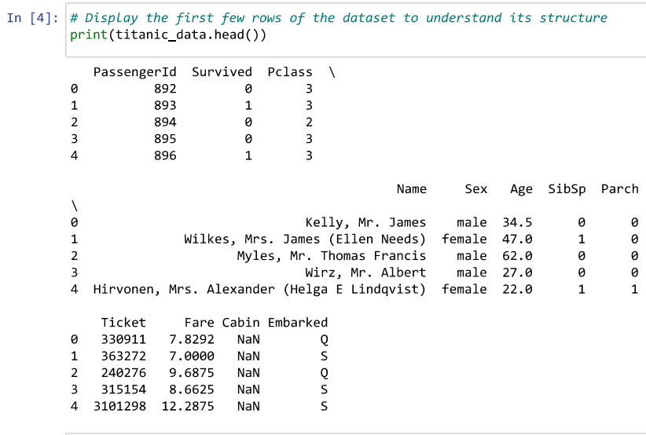

**Data Preprocessing:**

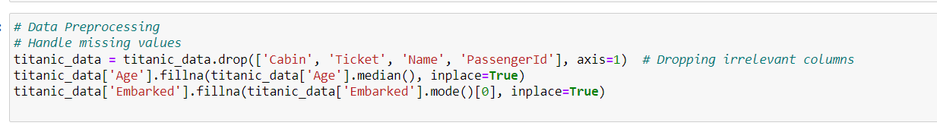

**Encode Categorical Variables:**

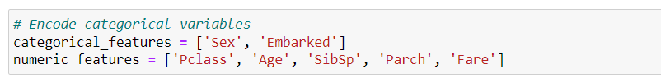

**Create a Column Transformer:**

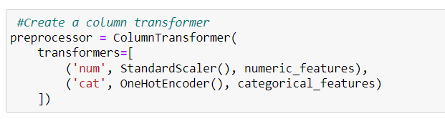

**Define the Model:**

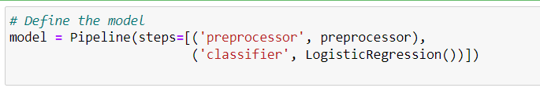

**Train-Test Split:**

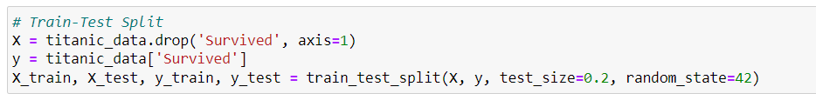

**Model Training**:

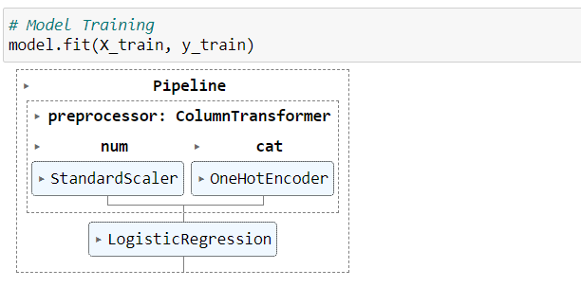

**Model Evaluation:**

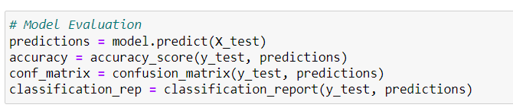

**Display Results:**

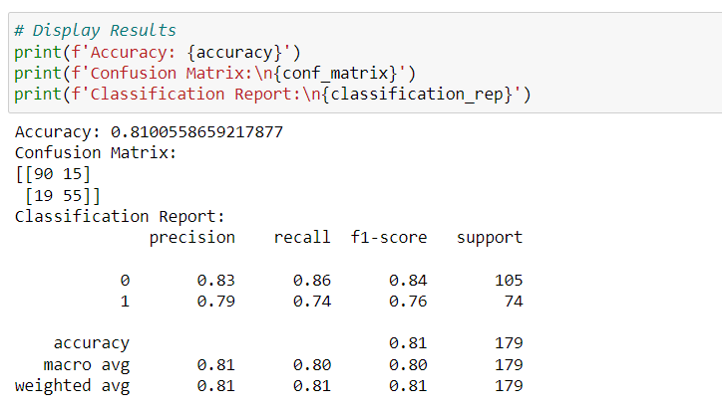

**Import and define Random Forest Model:**

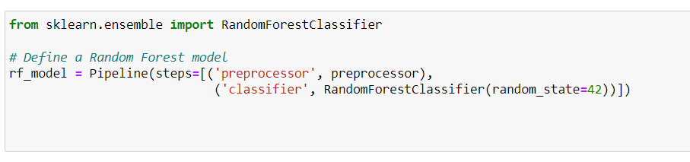

**Train Random Forest Model:**

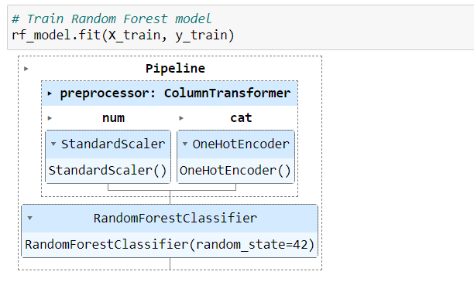

**Evaluate Random Forest model:**

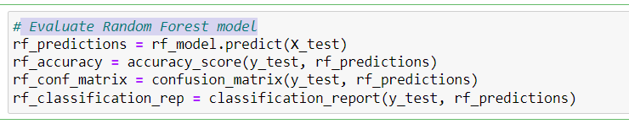

**Display Random Forest Results:**

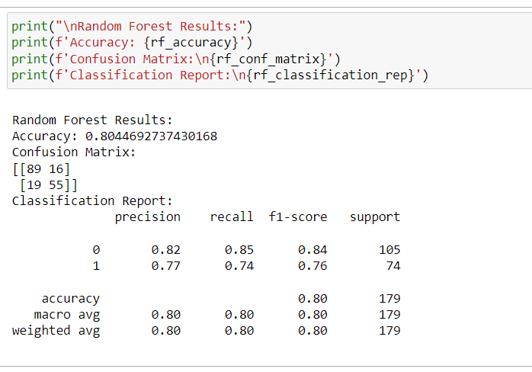

**Define a Support Vector Machine model:**

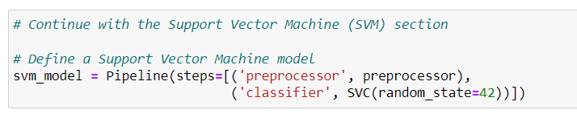

**Train Support Vector Machine model:**

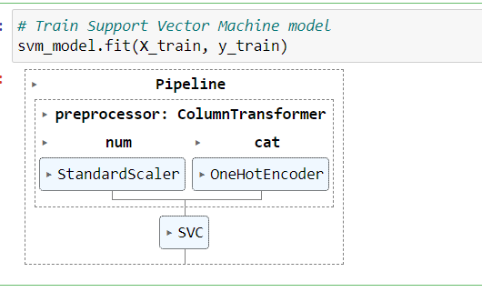

**Evaluate support vector machine model:**

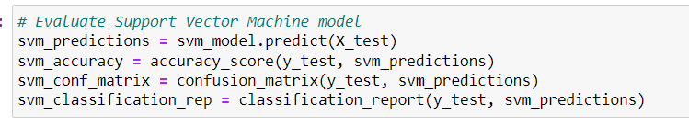

**Display Support Vector Machine Results:**

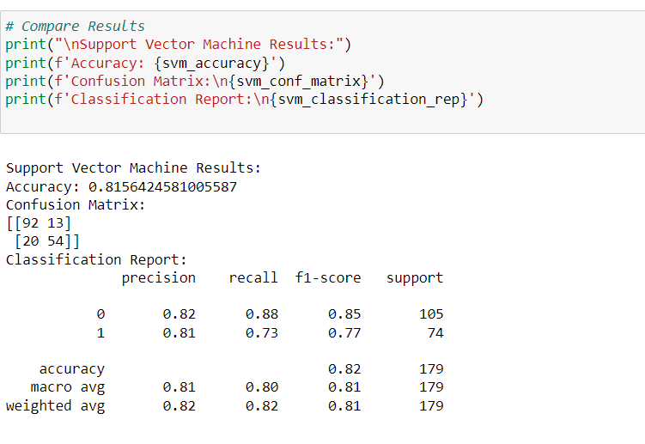

**Identify the best model based on accuracy:**

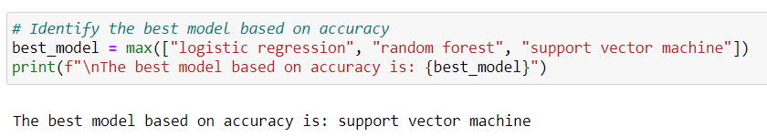

**Conclusion:**

Hence, we have successfully studied to implement Classification Modelling.